Significance of cloud computing to ensure Road Safety

Mohammad Abdur Rouf   
*Professor, department of Computer Science & Engineering*  
*Dhaka University of Engineering & Technology* Gazipur, Dhaka  
 marouf.cse@duet.ac.bd

*Abstract*— The rapid increase in the number of vehicles has given rise to traffic jams which affects the operation of ambulances. To avoid the traffic jam for the ambulance, a new idea is developed using Cloud computing, CCTV monitoring & image processing. Besides, road accidents are the become the main problem as the innovation and traffic is developed and road hazards have increased, causing more deaths due to the lack of timely support bureaus. Now a day's various sensors are available thus we can implement the concept of IoT so that we can leverage the nearby sensors to help the vehicles which have collided or are in need of any help. In case of an accident, there will be some collision in the vehicle which will be sensed by the sensors. The crash sensors will measure and report the intensity of collision based on certain parameters and operations related to the automotive design of the vehicle. This strength of collision mapped on a scale will then inform the respective nearby sensors in IoT which can come out to help the victims. This document aims to point out the significance of cloud computing by gathering the knowledge from the two concept of emergency traffic controlling system and IoT based emergency support when collision occurs on the road to ensure road safety thus the lives can be saved by ensuring an intelligent cloud computing system that can be developed using Cloud computing, Deep learning, Image processing, IoT, and different crash sensors.

Keywords— Cloud Computing, Internet of Things (IoT), Sensors, Wireless Sensor Network, Road Safety, Web Services, GPS, GSM, Accident Monitoring and Detection, Image processing, Object recognition.

# Introduction

Road traffic control is one of the important and challenging areas that involve directing vehicular and pedestrian traffic around a construction zone, accident or another road disruption, thus ensuring the safety of emergency response teams, construction workers, and the general public. Traffic control is an outdoor occupation, where an individual has to work night or day for long hours in all weathers, and is considered a dangerous occupation due to the high risk of being struck by passing vehicles [6-8]. Safety is very necessary for this kind of occupation and great care has to be taken. The traffic controller has to see all aspects and has to reduce the traffic jam which will affect the daily life of an individual. The critical conditions are when a traffic jam occurs and there is necessary to clear the traffic as an urgent work has to be carried out. The ambulance when got in traffic is a dangerous situation in which a patient might be forced to death as a result of late treatment, which is mainly due to traffic.

Earlier a major setback in the realization of any concept or a theory was the lack of availability of computing resources but now, with the introduction of these new technologies, we are able to introduce our concepts to the future world in no time. Nowadays, traffic has increased by a major proportion on the roads. As vehicles are becoming cheaper day by day, their number is increasing exponentially as mapped against the fixed number of roads. Now, this has resulted in a higher probability of accidents on the road costing many lives, for which the necessary measures should be taken.

Presently the vehicles are coming with a built-in accident tracking system that can detect accidents and can also trigger emergency help actions. Adoption of such systems is greatly discouraged and is therefore not very popular among the public. Major disadvantages of such systems comprise factors like non-portability, high cost, limited options, false delivery, etc. To overcome these authors have proposed a solution that leverages the power of nearby sensors to trigger help whenever an accident takes place. With the introduction of IPv6, unique IPs can be allocated to each and every sensor which can happen to be present in the nearby location. These sensors when interacting with one another result in the formation of the Internet of Things. Internet of Things is basically a group of entities that can interact with each other and can generate results without entirely depending on the availability of the internet. The entities involved in IoT here are sensors that can easily exchange small amounts of information. Whenever any accident will take place, the vehicle sensors will detect it and inform the nearby sensors about the accident. All of these sensors come under the shelter of IoT itself. Whenever an accident happens, we map its severity on a scale, and on the basis of that scale, we judge the severity of the accident. If the accident is not severe, then only the nearby sensors are informed about the accident so as to gather help. If the scale corresponds to a value of a major or severe accident, we inform the cloud server about the accident which triggers an emergency response.

We found numerous reasons that influence Road accidents such as,

1) Violations of Traffic Rules

2) Reckless driving

3) Over speeding

4) Illegal & Dangerous competition

5) Hazardous Road

6) Lacking vehicle fitness

7) Overloading

8) Overtaking

9) Driving a Long time without any break

10) Frequent change of lanes

11) Bad weather conditions etc.

# Problem Definition

Traffic has created a loss to mankind, by wasting time and

in case of accidents. In an emergency, as it comes to the case of the ambulance, this problem may cause a severe issue. Manual or traffic control lights may not work effectively. The ambulance has to wait and may cause a threat to the life of the patient. Even if the traffic is cleared there are some violations of rules which we cannot control. Thus in the proposed system in the methodology [1], traffic control is done automatically with the help of IoT, and necessary action is taken against the violators of the rule. On the other hand, In the case of accident lots of people need emergency support. Thus the proposed system in the methodology [2] developed a crash sensor-based system where sensors respond according to the intensity of the crash that happened then the corresponding accident level is computed and nearby help is called.

# Related Works

An increasing number of vehicles on the road has given rise to traffic jams. This affects the operation of an ambulance. To avoid the traffic jam for the ambulance, a new idea is proposed by the authors [1]. In this proposed system with the image processing, CCTV camera monitoring, sound detection & Cloud-Computing traffic can be controlled automatically and an announcement will be announced in case of an emergency ambulance pass. In this system, if any vehicle does not follow the announced instruction that vehicle will be detected by its CCTV camera monitoring system and then the number plate's number will be sent to the police station to take steps against him.

In the paper [2] authors implemented the concept of IoT, with the crash sensors. sensors will help the vehicles which have collided or are in need of any help. In case of an accident, there will be some collision in the vehicle which will be sensed by the sensors. The crash sensors will measure and report the intensity of collision based on certain parameters and operations related to the automotive design of the vehicle.

# Proposed System

## Methodology 1. (IoT based real time traffic control using cloud computing)

A CCTV and a microphone, which continuously monitors the traffic and sends the information to the processor for further processing. The image processing algorithms are implemented to detect the presence of the ambulance and audio processing is done to detect the siren. Once the vehicle is detected, the necessary signal is transmitted to the next station through the internet to indicate the arrival of the ambulance. The announcement of the ambulance arrival is notified by the speaker and all the vehicles are insisted to make way for the ambulance. A camera is installed to keep track of a vehicle that does not follow the announcement an image is captured and the number plate is extracted and owner information is passed on to the nearest police station through the internet to take further actions. Minimum of one parameter is sufficient to identify the vehicle, that is the image of the vehicle. By this, we can differentiate between the ambulance and other vehicles.

Implementation:

Opensource Matlab code is modified to use for image processing & audio processing to detect Ambulances & number plates and other vehicles. The data transfer between the two stations is demonstrated by using two computers which communicate through internet using TCP/IP. Cloud computing is used to store and control the information data and for further processing.

*Detection & Audio processing:*

The presence of an ambulance is detected by first recognizing the image. The following diagram shows the steps involved in the detection of the ambulance.

­­

Here authors employ thresholding, segmentation, and template matching to find the presence of ambulance. The traffic is continually under observation by the CCTV attached in the station which takes the real-time video of the traffic. The videos are used to detect the presence of an ambulance. The images extracted from the video, are in RGB format, which is converted to grayscale using the help of MATLAB commands. Thresholding-based image segmentation is done to divide the main image into several images, which is typically employed for object reorganization. At the final stage, the template matching is done in order to identify the required object.

The image from the camera is a color image that is converted to a gray image which is shown in Fig. 3. In this case, the image is taken from the internet for the convenience of demonstration. The gray image is segmented using the threshold-based segmentation with a threshold value of 50. Figure 4 shows the segmented image. Template matching is done in order to identify the ambulance in the traffic which is shown in Fig. 5. Once the ambulance is detected, then the next step is to find whether it is carrying the patient in it or not. For this purpose, audio reorganization techniques are used to identify the presence of a siren. If the ambulance is detected and the siren is also detected then the information is passed.

The pseudo code for ambulance detection is shown in

the Fig. 6, where the authors employ both object detection and audio reorganization to detect the presence of ambulance.

*Number plate detection & Extraction:*

To keep track of each action we use a camera at the station which continually captures video and is sent to the processing machine. If any violation of the rules is noticed, then the image is processed to obtain the information about the vehicles by extracting the number plate of the vehicle.

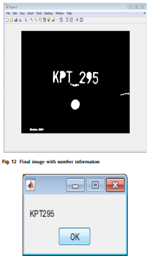

Fig. 8 Detected number from number plate

## Methodology 2. (Intelligent Accident Management System using IoT and Cloud Computing)

The model presented by the authors [2] involves a collective integration of different types of sensors as well as microcontroller units that acknowledge emergency calling systems. This technology includes the benefits of a GSM modem used as an automatic emergency calling system and a GPS sensor for location calling. GSM modem requires a SIM card and works with a GSM wireless network. Accelerometer sensors and vibration sensors are collaborated. Accelerometer sensors measure proper acceleration and when at rest on the Earth’s surface quantify an acceleration g=9.81 m/s2 straight upwards. Vibration sensors

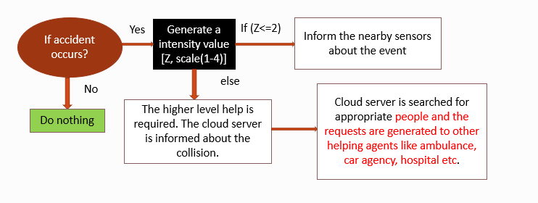

Fig. 9 Proposed model to determine collision intensity by the authors[2]

measure various physical parameters like changes in acceleration, temperature by converting them to an electrical signal. During an accident, the changes in g-forces (acceleration) in the vehicle are sensed by the accelerometer sensors. The flags are set on a microcontroller which is a single integrated circuit. It represents the data by setting the appropriate pin of the LED. Turned ON LED implies crash detection by vibration sensors. Therefore the microcontroller instructs the GSM modem and a message is sent to a predefined telephone number by the GSM modem. The estimate of g-forces measured by the accelerometer sensors can be used as a reference to be rated on a scale in order to provide an idea about the depth of the accident. For this purpose, the sensitivity of the accelerometers must be very high and must measure low-level accelerations precisely from d.c. up to 50Hz (or above). Also, they must be installed with high positional accuracy. Hence the accelerometer sensor module works as an important factor in the detection of a vehicle accident. This technique employs the use of Accelerometer based Transportation System commonly referred to as ATS. The model depicted at fig. 10.

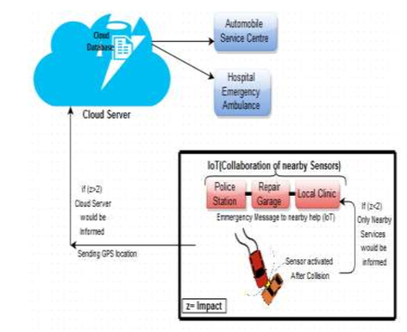

Fig. 10 Diagram representation of the whole system by the authors [2]

# Result Analysis

The estimate of g-forces measured by the accelerometer sensors can be used as a reference to be rated on a scale to provide an idea about the depth of the accident.

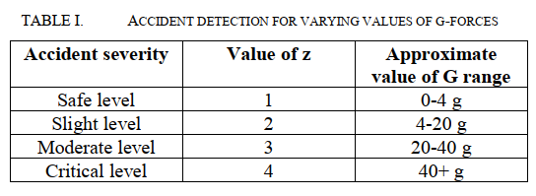

With the help of IoT, Cloud, and the Wireless Sensor Network. Given the idea that could be taken into the study using just the GSM modem and required sensors to globally interconnect with the IoT and the cloud because with the use of cloud computing, the higher impact i.e. the emergency could be monitored by the cloud server, saving the precious lives.

# Conclusion & Discussion

From paper [1] we found that with CCTV camera monitoring system, image processing, audio processing and Cloud-Computing can be used to solve ---

1. Violation of Traffic Rules
2. Illegal & dangerous competition
3. Overtaking recklessly
4. Long time driving without break

these situations. From paper [2] we found that sensors along with Cloud-Computing can be used to detect and respond to a vehicle collision. Thus, we can solve the situation when,

a) Reckless driving  
b) Over speeding  
c) Illegal & dangerous competition  
d) Overloading  
e) Frequent change of lane  
f) Bad weather condition and  
g) Collision detection and response accordingly happen.

So, we can conclude that to ensure Road Safety we need to deploy a system that uses**Cloud Computing**along with various **sensors**, **image-processing, audio-processing**&**image acquisition technique.**

Here, Cloud Computing can be used to enable and connect the devices to respond in real-time for the required action and image & the audio processing part also can be done in a cloud model easily where the cloud computing model could provide us---

1. Unlimited storage for images & audios to store

2. Deep learning & Machine learning tools, API’s for the processing purpose

3. Database to keep tracking the devices information and actions if anything happens.

##### Acknowledgment

The authors thank the Department of Computer Science and Engineering of Dhaka University of Engineering & Technology, Gazipur, for providing research support to continue the research work.

##### References

1. Vardhana, M., Arunkumar, N., Abdulhay, E., & Vishnuprasad, P. V. (2019). Iot based real time trafic control using cloud computing. *Cluster Computing*, *22*(1), 2495-2504.
2. Singhal, A., & Tomar, R. (2016, October). Intelligent accident management system using IoT and cloud computing. In 2016 2nd international conference on next generation computing technologies (NGCT) (pp. 89-92). IEEE.
3. Saxena, S. R., Singh, D., & Gupta, B. (2020). PREVENTING ROAD ACCIDENTS USING CLOUD COMPUTING. Turkish Journal of Computer and Mathematics Education (TURCOMAT), 11(3), 1406-1417.
4. Solaiman, K. M. A., Rahman, M. M., & Shahriar, N. (2013, May). Avra Bangladesh collection, analysis & visualization of road accident data in Bangladesh. In *2013 International Conference on Informatics, Electronics and Vision (ICIEV)* (pp. 1-6). IEEE.
5. Saxena, S. R., Singh, D., & Gupta, B. (2020). PREVENTING ROAD ACCIDENTS USING CLOUD COMPUTING. *Turkish Journal of Computer and Mathematics Education (TURCOMAT)*, *11*(3), 1406-1417.
6. Verroios, V., Vicente, C.R., Delis, A.: Detecting hazardous vehicles and disseminating their behavior in urban areas. In:  
   IEEE 13th International Conference on Mobile Data Management, pp. 280–281. (2012)
7. Saravanan, S.: Implementation of efficient automatic traffic surveillance using digital image processing. In: IEEE International Conference on Computational Intelligence and Computing Research. (2014)
8. Roy, A.B., Halder, A., Sharma, R., Hegde, V.: A Novel concept of smart headphones using active noise cancellation and speech recognition. In: International Conference on Smart Technologies and Management for Computing, Communication, Controls, Energy and Materials (ICSTM), pp. 366–371. (2015)